Kubernetes Dashboard

Check the cluster status

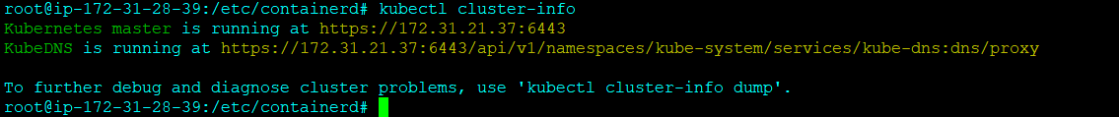

Create additional pods for dashboard

Influxdb.yaml – act as a storage engine for storing metrics

Heapster.yaml- collect metrics like CPU/Memory Utilization

Create pod

Now check the cluster status

View the dashboard

